**Centos7安装流媒体服务器平台**

1. **安装oneinstack脚本工具**

1.安装系统下载软件所必须的工具 yum -y install wget

2.任意选定一个文件夹，下载初始化的压缩包（oneinstack-full.tar.gz）

当前选定的文件夹为：/usr/local/src（统一选定文件夹）

3.下载初始化安装包：wget <http://mirrors.linuxeye.com/oneinstack-full.tar.gz>

4.下载完安装包之后，进行解压oneinstack-full.tar.gz

tar -xzvf oneinstack-full.tar.gz

进入解压之后的文件夹下进行初始化安装

cd oneinstack-full

./install.sh

1. **安装nginx-1.14服务器**
2. 进入选定文件夹/usr/local/src： cd /usr/local/src

2.安装PCRE库

下载安装包：wget ftp://ftp.csx.cam.ac.uk/pub/software/programming/pcre/pcre-8.40.tar.gz

解压到当前文件夹： tar -zxvf pcre-8.40.tar.gz  
进入解压文件夹： cd pcre-8.40  
对软件进行配置： ./configure  
编译安装： make && make install（可以分为两步执行）

3.安装zlib库

wget http://zlib.net/zlib-1.2.11.tar.gz  
tar -zxvf zlib-1.2.11.tar.gz  
cd zlib-1.2.11  
./configure  
make && make install

4.安装openssl库（这个库只需要解压即可）

wget https://www.openssl.org/source/openssl-1.1.0e.tar.gz

tar -zxvf openssl-1.1.0e.tar.gz

5.下载nginx-rtmp-module模块

git clone [https://github.com/arut/nginx-rtmp-module.git](https://github.com/arut/nginx-rtmp-module.git" \t "https://blog.csdn.net/tangyaliang11/article/details/_blank)

下载下来会自动生成文件夹 nginx-rtmp-module

6.源码编译nginx-1.14.0（这个版本是目前较为稳定的）

wget http://nginx.org/download/nginx-1.14.0.tar.gz  
tar -zxvf nginx-1.14.0.tar.gz  
cd nginx-1.14.0

./configure --prefix=/usr/local/nginx --with-http_ssl_module --with-pcre=/usr/local/src/pcre-8.40 --with-zlib=/usr/local/src/zlib-1.2.11 --with-openssl=/usr/local/src/openssl-1.1.0e --add-module=/usr/local/src/nginx-rtmp-module（注：这是一个命令）

make && make install

1. **安装jdk1.18_181**

1.先查看该系统中有没有java： 执行命令 java -version

情况一：

**检查卸载是否成功**

情况二：如下图所示

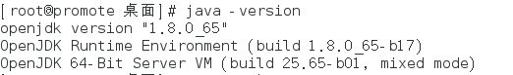

a.查看系统中java的包，运行命令：rpm -qa | grep java

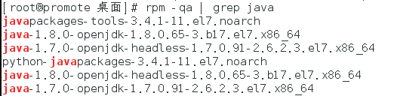

b.卸载系统中的java包

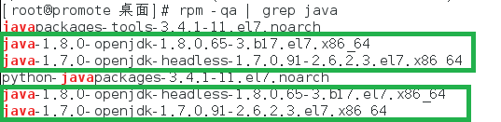

执行以下命令依次下载：

yum -y remove java-1.8.0-openjdk-1.8.0.65-3.b17.el7.x86_64

yum -y remove java-1.7.0-openjdk-headless-1.7.0.91-2.6.2.3.el7.x86_64

yum -y remove java-1.8.0-openjdk-headless-1.8.0.65-3.b17.el7.x86_64

yum -y remove java-1.7.0-openjdk-1.7.0.91-2.6.2.3.el7.x86_64

再一次查看java的版本，出现情况一的结果，则说明卸载完毕

2.下载项目所需的java

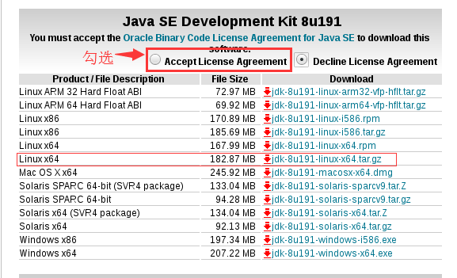

3.下载好安装包之后，进行解压

tar -xzvf jdk-8u191-linux-x64.tar.gz

4.配置java环境变量

vim /etc/profile 最后执行:source /etc/profile(让/etc/profile文件修改后立即生效)

在这个文件最后添加如下代码：

##java1.8

export JAVA_HOME=/usr/local/src/jdk1.8.0_191

export CLASSPATH=.:${JAVA_HOME}/jre/lib/rt.jar:${JAVA_HOME}/lib/dt.jar:${JAVA_HOME}/lib/tools.jar

export PATH=$PATH:${JAVA_HOME}/bin

5.检测java是否安装成功 java -version

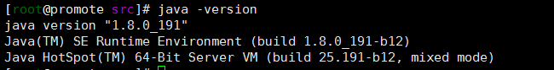

1. **安装apache-tomcat9**

1.利用Xshell软件，将apache-tomcat-9.0.13.tar.gz压缩包传至/usr/local/src文件夹下

2.解压这个压缩包 tar -xzvf apache-tomcat-9.0.13.tar.gz

3.为tomcat9配置环境变量

vim /etc/profile

在这个文件下添加如下代码：

##tomcat

CATALINA_HOME=/usr/local/src/apache-tomcat-9.0.13

CATALINA_BASE=/usr/local/src/apache-tomcat-9.0.13  
 PATH=$PATH:$CATALINA_BASE/bin  
 export PATH CATALINA_BASE

4.验证tomcat是否安装成功

cd apache-tomcat-9.0.13/bin

./startup.sh

出现以下情况则说明安装成功

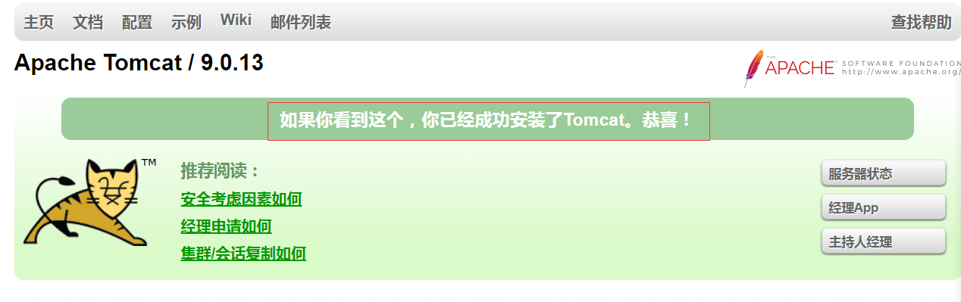

1. 安装apache-apollo1.7

1.利用Xshell软件，将apache-apollo-1.7.1-unix-distro.tar.gz压缩包传至/usr/local/src文件夹下

2.解压这个安装包 tar -xzvf apache-apollo-1.7.1-unix-distro.tar.gz

3.新建mybroker文件夹

cd /apache-apollo-1.7.1/bin

./apollo create mybroker

4.验证安装是否成功

cd /mybroker/bin

./apollo-broker run

1. 安装ffmpeg-2.8.15

****1.安装epel-release****

****[root@VM_0_10_centos ~]# yum install -y epel-release****

****Loaded plugins: fastestmirror, langpacks****

****Loading mirror speeds from cached hostfile****

****Resolving Dependencies****

****--> Running transaction check****

****---> Package epel-release.noarch 0:7-11 will be installed****

****--> Finished Dependency Resolution****

****Dependencies Resolved****

****======================================================================================****

****Package Arch Version Repository Size****

****======================================================================================****

****Installing:****

****epel-release noarch 7-11 epel 15 k****

****Transaction Summary****

****======================================================================================****

****Install 1 Package****

****Total download size: 15 k****

****Installed size: 24 k****

****Downloading packages:****

****epel-release-7-11.noarch.rpm | 15 kB 00:00:00****

****Running transaction check****

****Running transaction test****

****Transaction test succeeded****

****Running transaction****

****Installing : epel-release-7-11.noarch 1/1****

****Verifying : epel-release-7-11.noarch 1/1****

****Installed:****

****epel-release.noarch 0:7-11****

****Complete!****

****2.查看是否epel-release完成安装****

****[root@VM_0_10_centos ~]# yum repolist****

****Loaded plugins: fastestmirror, langpacks****

****Repository epel is listed more than once in the configuration****

****Loading mirror speeds from cached hostfile****

****repo id repo name status****

****【epel-release 安装成功】****

****epel/7/x86_64 EPEL for redhat/centos 7 - x86_64 12,723****

****extras/7/x86_64 Qcloud centos extras - x86_64 432****

****mysql-connectors-community/x86_64 MySQL Connectors Community 65****

****mysql-tools-community/x86_64 MySQL Tools Community 69****

****mysql57-community/x86_64 MySQL 5.7 Community Server 287****

****os/7/x86_64 Qcloud centos os - x86_64 9,911****

****updates/7/x86_64 Qcloud centos updates - x86_64 1,543****

****repolist: 25,030****

****3.安装nux-dextop 源****

****[root@VM_0_10_centos ~]# rpm --import http://li.nux.ro/download/nux/RPM-GPG-KEY-nux.ro****

****[root@VM_0_10_centos ~]#****

****rpm -Uvh http://li.nux.ro/download/nux/dextop/el7/x86_64/nux-dextop-release-0-1.el7.nux.noarch.rpm****

****Retrieving http://li.nux.ro/download/nux/dextop/el7/x86_64/nux-dextop-release-0-1.el7.nux.noarch.rpm****

****Preparing... ################################# [100%]****

****Updating / installing...****

****1:nux-dextop-release-0-1.el7.nux ################################# [100%]****

****4.查看nux-dextop 源是否安装****

****[root@VM_0_10_centos ~]# yum repolist****

****Loaded plugins: fastestmirror, langpacks****

****Repository epel is listed more than once in the configuration****

****Loading mirror speeds from cached hostfile****

****\* nux-dextop: li.nux.ro****

****nux-dextop | 2.9 kB 00:00:00****

****nux-dextop/x86_64/primary_db | 1.8 MB 00:00:04****

****【安装成功】****

****repo id repo name status****

****epel/7/x86_64 EPEL for redhat/centos 7 - x86_64 12,723****

****extras/7/x86_64 Qcloud centos extras - x86_64 432****

****mysql-connectors-community/x86_64 MySQL Connectors Community 65****

****mysql-tools-community/x86_64 MySQL Tools Community 69****

****mysql57-community/x86_64 MySQL 5.7 Community Server 287****

****nux-dextop/x86_64 Nux.Ro RPMs for general desktop use 2,677****

****os/7/x86_64 Qcloud centos os - x86_64 9,911****

****updates/7/x86_64 Qcloud centos updates - x86_64 1,543****

****repolist: 27,707****

****5.安装ffmpeg****

****[root@VM_0_10_centos ~]# yum install -y ffmpeg****

****Loaded plugins: fastestmirror, langpacks****

****Repository epel is listed more than once in the configuration****

****Loading mirror speeds from cached hostfile****

****\* nux-dextop: li.nux.ro****

****Resolving Dependencies****

****--> Running transaction check****

****...****

****省略****

****...****

****speex.x86_64 0:1.2-0.19.rc1.el7****

****trousers.x86_64 0:0.3.14-2.el7****

****vo-amrwbenc.x86_64 0:0.1.2-1.el7.nux****

****x264-libs.x86_64 0:0.142-11.20141221git6a301b6.el7.nux****

****x265-libs.x86_64 0:1.9-1.el7.nux****

****xvidcore.x86_64 0:1.3.2-5.el7.nux****

****Complete! 【安装完成】****

****6.查看ffmpeg版本****

****[root@VM_0_10_centos ~]# ffmpeg -version****

****ffmpeg version 2.8.15 Copyright (c) 2000-2018 the FFmpeg developers****

****built with gcc 4.8.5 (GCC) 20150623 (Red Hat 4.8.5-28)****

****configuration: --prefix=/usr --bindir=/usr/bin --datadir=/usr/share/ffmpeg --incdir=/usr/include/ffmpeg --libdir=/usr/lib64 --mandir=/usr/share/man --arch=x86_64 --optflags='-O2 -g -pipe -Wall -Wp,-D_FORTIFY_SOURCE=2 -fexceptions -fstack-protector-strong --param=ssp-buffer-size=4 -grecord-gcc-switches -m64 -mtune=generic' --extra-ldflags='-Wl,-z,relro ' --enable-libopencore-amrnb --enable-libopencore-amrwb --enable-libvo-amrwbenc --enable-version3 --enable-bzlib --disable-crystalhd --enable-gnutls --enable-ladspa --enable-libass --enable-libcdio --enable-libdc1394 --disable-indev=jack --enable-libfreetype --enable-libgsm --enable-libmp3lame --enable-openal --enable-libopenjpeg --enable-libopus --enable-libpulse --enable-libschroedinger --enable-libsoxr --enable-libspeex --enable-libtheora --enable-libvorbis --enable-libv4l2 --enable-libx264 --enable-libx265 --enable-libxvid --enable-x11grab --enable-avfilter --enable-avresample --enable-postproc --enable-pthreads --disable-static --enable-shared --enable-gpl --disable-debug --disable-stripping --shlibdir=/usr/lib64 --enable-runtime-cpudetect****

****libavutil 54. 31.100 / 54. 31.100****

****libavcodec 56. 60.100 / 56. 60.100****

****libavformat 56. 40.101 / 56. 40.101****

****libavdevice 56. 4.100 / 56. 4.100****

****libavfilter 5. 40.101 / 5. 40.101****

****libavresample 2. 1. 0 / 2. 1. 0****

****libswscale 3. 1.101 / 3. 1.101****

****libswresample 1. 2.101 / 1. 2.101****

****libpostproc 53. 3.100 / 53. 3.100****